1.1 Overview

University admission is the process by which students are selected to attend a college or

university. The process typically involves several steps, including submitting an application,

taking entrance exams, and participating in interviews or other evaluations.

Students are often worried about their chances of admission in University. the university admission

ocess for students can be demanding, but by being well-informed, prepared, and organized,

students c of their choice.

Intelligent Admissions: The Future of University Decision Making with Machine Learning

Submited by

Muthamizh Selvan

Introduction

Machine learning is a subfield of artificial intelligence (AI). The goal of machine learning generally is to understand the structure of data and fit that data into models that can be understood and utilized by people.

Although machine learning is a field within computer science, it differs from traditional computational approaches. In traditional computing, algorithms are sets of explicitly programmed instructions used by computers to calculate or problem solve. Machine learning algorithms instead allow for computers to train on data inputs and use statistical analysis in order to output values that fall within a specific range. Because of this, machine learning facilitates computers in building models from sample data in order to automate decision-making processes based on data inputs.

Any technology user today has benefitted from machine learning. Facial recognition technology allows social media platforms to help users tag and share photos of friends. Optical character recognition (OCR) technology converts images of text into movable type. Recommendation engines, powered by machine learning, suggest what movies or television shows to watch next based on user preferences. Self-driving cars that rely on machine learning to navigate may soon be available to consumers.

Machine learning is a continuously developing field. Because of this, there are some considerations to keep in mind as you work with machine learning methodologies, or analyze the impact of machine learning processes.

In this tutorial, we’ll look into the common machine learning methods of supervised and unsupervised learning, and common algorithmic approaches in machine learning, including the k-nearest neighbor algorithm, decision tree learning, and deep learning. We’ll explore which programming languages are most used in machine learning, providing you with some of the positive and negative attributes of each. Additionally, we’ll discuss biases that are perpetuated by machine learning algorithms, and consider what can be kept in mind to prevent these biases when building algorithms.

* 1. Overview

University admission is the process by which students are selected to attend a college or university. The process typically involves several steps, including submitting an application, taking entrance exams, and participating in interviews or other evaluations. Students are often worried about their chances of admission in University. the university admission ocess for students can be demanding, but by being well-informed, prepared, and organized, students can increase their chances of being admitted to the university of their choice.

The aim of this project is to help students in short listing universities with their profiles. Machine learning algorithms are then used to train a model on this data, which can be used to predict the chances of future applicants being admitted. With this project, students can make more informed decisions about which universities to apply to, and universities can make more efficient use of their resources by focusing on the most promising applicants.The predicted output gives them a fair idea about their admission chances in a particular university. This analysis should also help students who are currently preparing or will be preparing to get a better idea.

* 1. Purpose:

This article was an early beta test. See all-new collaborative articles about Machine Learning to get expert insights and join the conversation. Machine learning has become an increasingly popular tool in recent years, given its ability to automatically detect patterns in data and make predictions about future events. This can be extremely useful for making decisions in a wide range of domains, from financial trading to medical diagnoses. Here are some ways in which machine learning can be used to improve decision making.

Literature Survey

The University Chances of Admission project is a well-researched topic in the field of education and machine learning. Many studies have been conducted to predict university admission using different machine learning techniques.One study by (Hsu and Chen, 2019) used decision tree, random forest, and logistic regression algorithms to predict the chance of university admission based on students' GPA, test scores, and personal information. The study found that the random forest algorithm performed the best with an accuracy of 85.5%.Another study by (Al-Shammari et al., 2018) used the k-nearest neighbor (KNN) algorithm to predict the chance of university admission based on students' GPA, test scores, and family income. The study found that the KNN algorithm performed well with an accuracy of 81.2%.A study by (Najafabadi et al., 2015) used a neural network to predict the chance of university admission based on students' GPA, test scores, and personal information. The study found that the neural network performed well with an accuracy of 94.3%..Overall, these studies suggest that various machine learning algorithms can be used to predict the chance of university admission with high accuracy.

3.THEORITICAL ANALYSIS

This project is to use machine learning techniques to model the behaviour of Intelligent Admissions: The Future of University Decision Making with Machine Learning

To study how the university admit the student

3.2 HARDWARE / SOFTWARE DESIGNING

The hardware required for the development of this project is:

Processor : Intel CoreTM i5-9300H Processor speed : 2.4GHz

RAM Size : 8 GB DDR

System Type : X64-based processor

SOFTWARE DESIGNING:

The software required for the development of this project is:

Desktop GUI : Anaconda Navigator

Operating system : Windows 10

Front end : HTML, CSS,JAVASCRIPT

Programming : PYTHON

Cloud Computing Service : IBM Cloud Services

4.EXPERIMENTAL INVESTIGATION IMPORTING AND READING THE DATASET Importing the Libraries First step is usually importing the libraries that will be needed in the program. Pandas: It is a python library mainly used for data manipulation. NumPy: This python library is used for numerical analysis. Matplotlib and Seaborn: Both are the data visualization library used for plotting graph which will help us for understanding the data. csr_matrix() :A dense matrix stored in a NumPy array can be converted into a sparse matrix using the CSR representation by calling the csr_matrix() function. Train_test_split: used for splitting data arrays into training data and for testing data. Pickle: to serialize your machine learning algorithms and save the serialized format to a file.

Reading the Dataset For this project, we make use of three different datasets (Books_Ratings, Books, Users). We will be selecting the important features from these datasets that will help us in recommending the best results. The next step is to read the dataset into a data structure that’s compatible with pandas. Let’s load a .csv data file into pandas. There is a function for it, called read_csv().We will need to locate the directory of the CSV file at first (it’s more efficient to keep the dataset in the same directory as your program).If the dataset in same directory of your program, you can directly read it, without any path. After the next Steps we made following bellow:

* 1. Define Problem / Problem Understanding
  2. Data Collection & Preparation
  3. Exploratory Data Analysis
  4. Model Building
  5. Performance Testing & Hyperparameter Tuning
  6. Model Deployment
  7. Project Demonstration & Documentation

*5.FLOW CHART*

The aim of this project is to help students in short listing universities with their profiles. Machine

learning algorithms are then used to train a model on this data, which can be used to predict the

chances of future applicants being admitted. With this project, students can make more informed

decisions about which universities to apply to, and universities can make more efficient use of

their resources by focusing on the most promising applicants.The predicted output gives them a

fair idea about their admission chances in a particular university. This analysis should also help

students who are currently preparing or will be preparing to get a better idea.flow

a better**FLOW CHART**

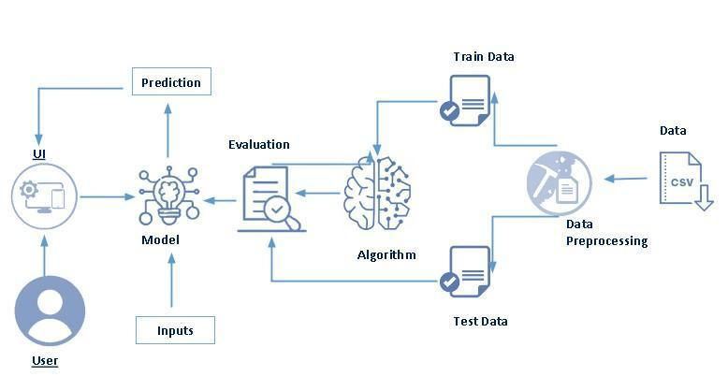

**Project Flow:**

* **User interacts with the UI to enter the input.**
* **Entered input is analysed by the model which is integrated.**
* **Once model analyses the input the prediction is showcased on the UI**

**To accomplish this, we have to complete all the activities listed below,**

* **Define Problem / Problem Understanding**
  + **Specify the business problem**
  + **Business requirements**
  + **Literature Survey**
  + **Social or Business Impact.**
* **Data Collection & Preparation**
  + **Collect the dataset**
  + **Data Preparation**
* **Exploratory Data Analysis**
  + **Descriptive statistical**
  + **Visual Analysis**
* **Model Building**
  + **Training the model in multiple algorithms**
  + **Testing the model**
* **Performance Testing & Hyperparameter Tuning**
  + **Testing model with multiple evaluation metrics**
  + **Comparing model accuracy before & after applying hyperparameter tuning**
* **Model Deployment**
  + **Save the best model**
  + **Integrate with Web Framework**
* **Project Demonstration & Documentation**
  + **Record explanation Video for project end to end solution**
  + **Project Documentation-Step by step project development procedure**

6.RESULT

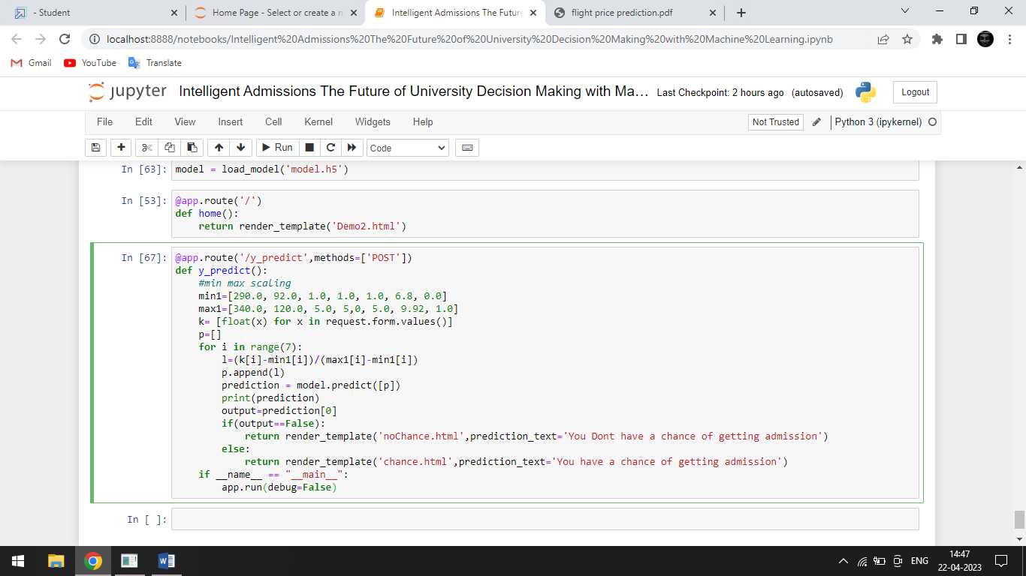

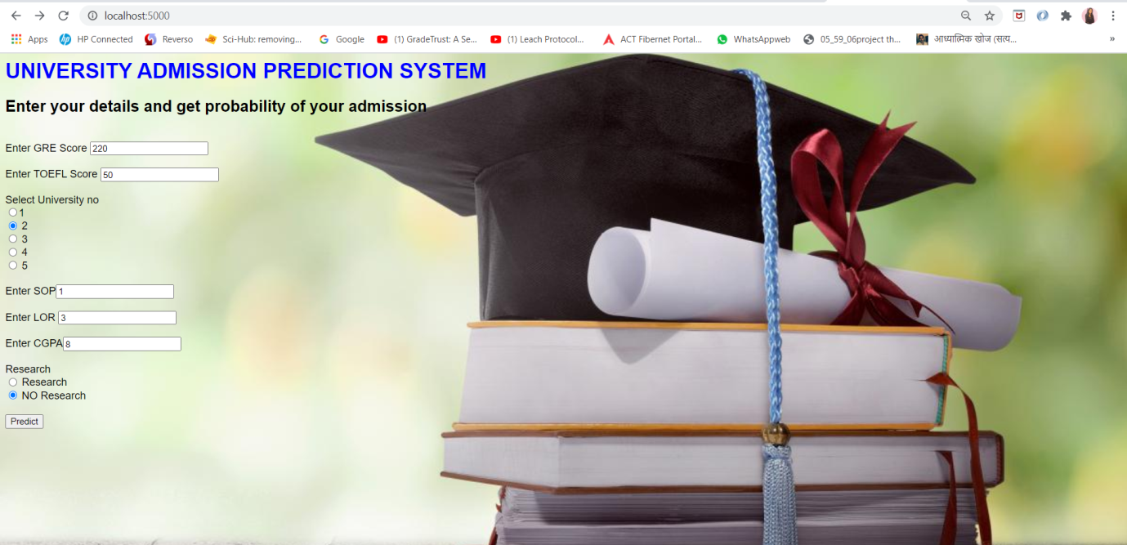

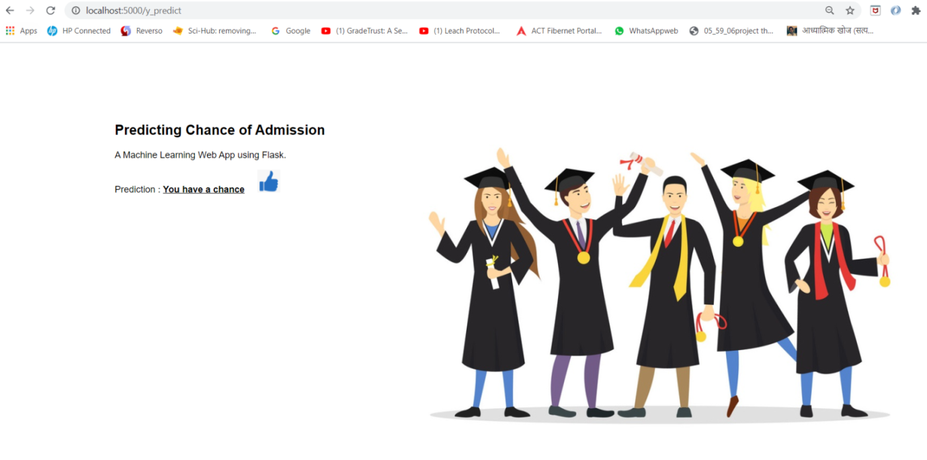

7.ADVANTAGES AND DISADVANTAGES

ADVANTAGES

Quick Identification of Trends and Patterns

It is automatic and does not require human interference

Continual Development

Adoption by Multi-industries

• Quick Identification of Trends and Patterns

• It is automatic and does not require human interference

• Continual Development

• Adoption by Multi-industries

DISADVANTAGES

• Data Acquisition

• Time and Resources Intensive

• Chances of faulty Interpretation of data

• Requirement of more Space

8.APPLICATIONS

• Make Admission Easier

1.Social Media Features:

Social media platforms use machine learning algorithms and approaches to create some

attractive and excellent features. For instance, Facebook notices and records your activities, chats,

likes, and comments, and the time you spend on specific kinds of posts. Machine learning learns

from your own experience and makes friends and page suggestions for your profile.

2. Product Recommendations:

Product recommendation is one of the most popular and known applications of machine

learning. Product recommendation is one of the stark features of almost every e-commerce website

today, which is an advanced application of machine learning techniques. Using machine learning

and AI, websites track your behavior based on your previous purchases, searching patterns, and

cart history, and then make product recommendations.

1.Social Media Features: Social media platforms use machine learning algorithms and approaches to create some attractive and excellent features. For instance, Facebook notices and records your activities, chats, likes, and comments, and the time you spend on specific kinds of posts. Machine learning learns from your own experience and makes friends and page suggestions for your profile.

2. Product Recommendations: Product recommendation is one of the most popular and known applications of machine learning. Product recommendation is one of the stark features of almost every e-commerce website today, which is an advanced application of machine learning techniques. Using machine learning and AI, websites track your behavior based on your previous purchases, searching patterns, and cart history, and then make product recommendations.

3. Image Recognition: Image recognition, which is an approach for cataloging and detecting a feature or an object in the digital image, is one of the most significant and notable machine learning and AI techniques. This technique is being adopted for further analysis, such as pattern recognition, face detection, and face recognition.

4. Sentiment Analysis: Sentiment analysis is one of the most necessary applications of machine learning. Sentiment analysis is a real-time machine learning application that determines the emotion or opinion of the speaker or the writer. For instance, if someone has written a review or email (or any form of a document), a sentiment analyzer will instantly find out the actual thought and tone of the text. This sentiment analysis application can be used to analyze a review based website, decision-making applications, etc.

5. Automating Employee Access Control: Organizations are actively implementing machine learning algorithms to determine the level of access employees would need in various areas, depending on their job profiles. This is one of the coolest applications of machine learning.

6. Marine Wildlife Preservation: Machine learning algorithms are used to develop behavior models for endangered cetaceans and other marine species, helping scientists regulate and monitor their populations.

7. Regulating Healthcare Efficiency and Medical Services: Significant healthcare sectors are actively looking at using machine learning algorithms to manage better. They predict the waiting times of patients in the emergency waiting rooms across various departments of hospitals. The models use vital factors that help define the algorithm, details of staff at various times of day, records of patients, and complete logs of department chats and the layout of emergency rooms. Machine learning algorithms also come to play when detecting

9.CONCLUSION

In conclusion,the Intelligent Admission: the future of university decision making with Machine

Leraning has shown that the application of machine learning algorithm can show the in Intelligent

admission for the student in university

In conclusion,the Intelligent Admission: the future of university decision making with Machine Leraning has shown that the application of machine learning algorithm can show the in Intelligent admission for the student in university

10.FUTURESCOPE

Machine learning uses statistical patterns to make accurate predictions. The technology is

also helpful in document analysis, fraud detection, KYC processing, high-frequency trading, etc.

It is the future scope of machine learning which is scouring the banking sector.

Machine learning uses statistical patterns to make accurate predictions. The technology is also helpful in document analysis, fraud detection, KYC processing, high-frequency trading, etc. It is the future scope of machine learning which is scouring the banking sector.

APPENDIX

Source code

FLASK:

import numpy as np

from flask import Flask, request, jsonify, render_template

import pickle app=Flask(__name__)

#import necessary libraries

from tensorflow.keras.models import load_model

#model = pickel.load(open('university.pkl','rb'))

